REQUEST FOR EXPRESSIONS OF INTEREST

AFRICAN LEGAL SUPPORT FACILITY (ALSF)

CONSULTING FIRM TO PROVIDE SUPPORT AND MAINTENANCE SERVICES FOR THE AMLA WEBSITE

Terms of Reference

- Background information about ALSF and the AMLA Project
The African Legal Support Facility (“ALSF” or “Facility”) is an international organisation established by a Treaty in 2008. The Facility is hosted by the African Development Bank. Its membership is open to (a) All AfDB Member States (b) other states (c) AfDB and (d) other international organisations or institutions. The ALSF’s main objectives include: (i) assisting the AfDB’s Regional Member Countries (RMCs) address litigation brought against them by vulture funds (and other such entities); (ii) creating an avenue for the AfDB's RMCs to access technical advice when negotiating complex commercial transactions (especially in the area of infrastructure and natural resources); and (iii) investing in and organizing the training of legal counsel from participating RMCs to equip them with the legal expertise necessary to better represent their countries.
AMLA is a legislation gathering, organization, dissemination, capacity building and capacity utilization Project with three main activities: namely (i) the creation of the AMLA platform, a free online one-stop resource for Africa’s mining legal framework (mining code, regulations and related legislation) with interactive features to provide comparative data; (ii) production of the Guiding Template, an annotated document that outlines a menu of legislative solutions to assist countries in the preparation or revision of their mining laws; and (iii) capacity building through training (on-ground and remotely) of African legal professionals in the use of the online platform and on overall issues in mining law.
The Facility is currently recruiting a Consultant Firm to provide support and maintenance services for the AMLA Website.

- Duties and responsibilities
Under the direct supervision of the Director of the Facility, the Consultant Firm will provide the following support and maintenance services for the AMLA Website:
- Content Management
The Consultant shall provide content management services as part of the monthly support. This includes changing of text, images, videos and ordering of information on the “AMLA Home”, “Highlights” or news section, “About AMLA”, “What’s New” and Social Media pages as well as amendments of country specific text and the Guiding Template. Content management shall also include addition of pages to the site, editing of pages to accommodate changes and provision of page designs and graphics to ensure new pages maintain a professional and attractive look whilst maintaining the core message intended for AMLA's web audience.
- Website Feature Updates
Through the website support package, the Consultant shall provide feature upgrades to both the front and back ends of the AMLA site for purposes of positioning the site to maximise its impact. These feature upgrades will include but not be limited to 5 technologies namely: (i) Resource Contracts API, (ii) Extractives Hub API, (iii) AMLA Database, (iv) AMLA Backend Redesign/update and (v) AMLA frontend redesign.
- Third Party Software Management
The Consultant shall develop an eLearning platform using third-party applications and software packages.
Periodically new patch releases shall be made available to enhance performance or bring the feature levels up to date.
As part of the support agreement, the Consultant shall ensure all new releases are presented to the ALSF along with associated risks and benefits. Updates shall be applied at a mutually agreeable time to ensure minimal disruption to learning.
- Online Trouble Ticket System
The Consultant shall provide access to its ticket system to enable users and partners to raise trouble tickets as and when required. This shall form the basis of the Service Level Agreement (SLA) and its associated adherence.
- Monthly Support Meetings
The Consultant shall attend monthly skype meetings with the ALSF whereby the key tickets from the month shall be discussed and SLA adherence would be reviewed.
Monitoring of the SLA would take place and, where appropriate and applicable, an investigation on any failures to adhere to the SLA shall be conducted.
- Office Hours Helpdesk
The Consultant shall provide an office hours helpdesk support between 8:00 and 18:00 Abidjan Time, Monday to Friday.
Access to the helpdesk shall be via the Consultant’s own hotline service, Skype, Email or WhatsApp. This number shall be provided to the Facility’s point of contact for easy communication.
- Service Level Agreement
All support requests and tickets raised shall be subject to the Service Level Agreement. This shall dictate the initial response and time to resolve all tickets.
Each month, a dashboard report of all issues raised and the associated response time and solution shall be provided to the ALSF. Allocation and prioritization of issues raised shall be done according to the following matrix:
Priority | Description | SLA | Expectations
Emergency  System Down | Host outage - Major system failure causing system to go offline due to outage by Digital Ocean | Customer will receive a response on email within an hour and the support team will immediately contact the host and push for a swift resolution. | Requires maximum effort from the Consultant
Priority 1  Critical Impact e.g. System Down | Major system failure causing the system to go offline.  Follow up and feedback on what caused the site failure | Customer will receive a response on email within 8 hours providing feedback on what caused the outage and what has been done to prevent future outages. | Requires maximum effort from the Consultant until an emergency fix or actual solution is put in place and site made available.  The Consultant shall provide updates on an hourly basis by email.
Priority 2  Serious/Urgent | Major feature failure. The program is usable but severely limited. E.g. can’t load map on projects. | Customer shall receive a response within 2 hours and prioritize resolving such tickets. | Requires intensive effort support until failing features are live / back up.  Priority 1 tickets shall be downgraded once work around is initiated.  The consultant shall provide an update on the resolution progress every 4 hours.  Aim to put a solution in place within 2 days.
Priority 3  Low / Minor Impact  Minor performance degradation | System is up and running, but the problem causes minor impact to the users’ ability to utilize the platform e.g. pictures not loading. | Customer will receive a response from support within 4 hours. | Requires moderate effort to trouble shoot and follow up on factors outside the system such as users’ internet bandwidth.  Report every 2 days  Solution within 5 days

- Website Availability
The Consultant shall keep the AMLA website connected to their availability monitoring tool to monitor uptime and proactively contact the host in case of outages or slow speeds for more than 15 minutes.
- Hosting Solution
The Consultant shall provide hosting services as part of its support plan, whose deliverables will include:
- Management payment of the account and factor in the cost in the monthly support invoice submitted to the ALSF;
- Raise tickets in case of slow speed or downtime and follow these up directly with the hosting service supplier; and
- Confirm weekly backup of the site.

- Communication
The Consultant shall make use of appropriate communication tools to ensure efficient flow of information with the project team and other stakeholders. These tools shall include, basecamp, skype, trello, gumzo, email and whatsapp.
The communication schedule shall involve the following frequency and agenda:
Frequency | Agenda | Attendees
Quarterly | Full review of platform:  - Key issues  - Google stats  - Feature development  - Plans for coming quarter | ALSF AMLA Team &  The Consultant
Monthly | - Status review and check-in to ensure all key actions are on track | Key members of ALSF AMLA Team &  The Consultant
Ad Hoc | - Emergency issue resolution  - New feature requests | Key members of ALSF &  The Consultant

- Training
- User Guide
A user guide (see Annex) shall be updated as and when required and the latest version provided to all stake holders and made available for download on the platform.
The user guide will instruct the user on how to utilize the platform CMS.
- Face to Face Training
The Consultants shall deliver an annual Legal Research Team (LRT) training on the Content Management System (CMS) as part of the induction process.
- eLearning
The Consultants shall develop a Learning Management System (LMS) with access to the AMLA training material.
- Google Analytics
- Weekly Report
The Consultant shall develop a bespoke Google analytics dashboard to provide the ALSF with information on the utilization of the website. This report shall be configured to be sent each week to a specified distribution list.
- Monthly Analysis Report
Each month, the Consultant shall develop an Analysis Report based on the previous month’s statistics. This report shall seek to highlight trends and make any recommendations on SEO activities.
- SEO & Website Strategy
The Consultant shall implement best practice activities for the website’s SEO as part of the support package. The Consultant shall also set actions from the Google statistics recommendations to ensure the site is technically well equipped to achieve its objectives and perform well across search engines.
- Corporate Designs Support
The Consultant shall support the ALSF with the preparation of stationery designs. These include AMLA event fliers, such as workshop fliers, PowerPoint, Word template designs, and AMLA Workshop folder designs.

- Qualifications and Experience Required

- Staff with at least a Master’s degree in computer science, programming, information technology, communications or a related field;
- Minimum of five (5) years of relevant work experience in web development;
- Graphic design and implementation of information-rich, user-friendly and large websites;
- Proven experience in the web development field with a solid portfolio of accomplished web projects (applicant has to present at least five (5) similar scoped websites developed);
- Demonstrated effective coordination skills and an ability to work under pressure in a multicultural environment to complete multiple tasks and meet deadlines;
- Advanced proficiency with HTML, including style sheets, templates, complex tables and image maps. Must possess working knowledge of basic composition, page layout, art and office/web software packages such as MS Word, Excel, Dreamweaver, Adobe PageMaker, Illustrator, Photoshop and Acrobat (or Open Source Software equivalents);
- Experience in web behavior knowledge and web development programming languages (PHP, perl, ASP, SQL, Python, JSP etc.);
- Knowledge of WII framework will be an asset
- Experience with photographic manipulation, digital painting. Digital audio and video experience highly desirable;
- Experience with new media technologies, including RSS, Twitter, Podcasts etc., highly desirable;
- Experience with web servers (Apache, Tomcat, IIS, Zope etc.);
- Excellent written and verbal communication skills in English and in French.

- Location
The consultant will perform the work remotely.

- Duration of Assignment and expected time of commencement

The assignment will last for twelve (12) months and the estimated start date is 15 October 2019.

- Remuneration
The consultant shall be paid a lump sum, comprising fee and expenses, for the duration of the assignment.

- Expressions of Interest and Submission of Proposals

Expressions of Interest and submission of Technical and Financial Proposals must be received jointly by email at the address below no later than 27 September 2019 at 17h00 Abidjan time. Expressions of Interest and Proposals must specifically mention “AMLA IT Consulting Firm – Expression of Interest and Proposals”.

To the attention of: Mr. Thierno OLORY-TOGBE
African Development Bank
African Legal Support Facility (ALSF)
CCIA Plateau, 01 B.P. 1387
Abidjan 01, Côte d’Ivoire
E-mail: t.olory-togbe@afdb.org / alsf@afdb.org

Any questions can be directed to Ms. Mariame BAH ( m.bah@afdb.org) with copy to Ms. Noellie GAH (n.gah@afdb.org) and Mr. Thierno OLORY-TOGBE (t.olory-togbe@afdb.org).

- Evaluation Criteria

Technical and financial proposals will be evaluated based on the following criteria:

Criteria | Weight
Technical Proposal | 70%
Experience relevant to the assignment | 10%
Understanding of the terms of reference and methodology | 20%
Qualifications of the Key personnel | 20%
Experience with the ALSFs and International Financial Institutions | 10%
Specific experience on e-learning platform design and development | 10%
Financial Proposal | 30%
TOTAL | 100%

ANNEX : AMLA PLATFORM USER GUIDE

Contents
1 Introduction 3
1.1 Home Page 3
1.2 Country Pages 6
1.3 View Legislation 7
1.3.1 Navigate Content 8
1.3.2 Search Content 10
1.3.3 Print and Download Document 10
1.4 Country Comparison Feature 11
1.4.1 Step 1 – Select Countries 11
1.4.2 Step 2 – Select Common Taxonomy Criteria 12
1.4.3 Step 3 – Compare 13
1.4.4 Step 4 – Save Results 14
1.4.5 Step 5 – Update Comparison Query 14
2 Contributor Functionality 16
2.1 TOP Tip 16
2.2 Login 16
2.3 Edit Country Details 17
3 Create Primary Legislation and or Primary Regulations 20
3.1.1 Document Hierarchy 21
3.2 Create the Document Content 21
3.2.1 Add Preamble 23
3.2.2 Add Chapter 23
3.2.3 Add Part 25
3.2.4 Add Section 28
3.2.5 Add Article 28
3.3 Submit for Review 30
4 Create Related Legislative and Regulatory Documents 34
4.1 Submit for Review 34
5 Add Comparison Text 37
5.1 Add Comparison 37
5.1.1 Full Section to be Used 38
5.1.2 Partial Section to be Used 38
5.1.3 Multiple Sections Relating to One Topic 38
5.2 Submit Comparison Text for Review 39
6 Manage Review Comments 40
6.1 LRD Review Edits 40
6.1.1 Review Results 40
6.1.2 Make Edits 41
6.1.3 Complete Review 43
6.1.4 Add your own Comments 44
6.1.5 Resubmit for Review 46
6.2 Comparison Text Review Edits 46
6.2.1 Review Results 46
6.2.2 Make Edits 48
6.2.3 Complete Review 50
6.2.4 Add your own Comments 51
6.2.5 Resubmit for Review 55

Introduction
The AMLA platform is a web based platform that enables users to quickly and effectively access the national mining acts, amendments, associated regulations and mining legislation of all African states in a single online repository.

Home Page
When a user launches the AMLA platform at http://www.a-mla.org they will be presented with the following screen.
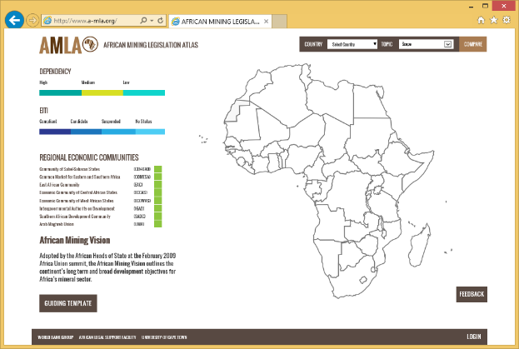
The home page shows an interactive map of the African content.
A user can hover over each country causing a pop-up to appear highlighting the non-fuel minerals found in each country, the countries dependency on non-fuel minerals and their EITI status (see the following screen shot).
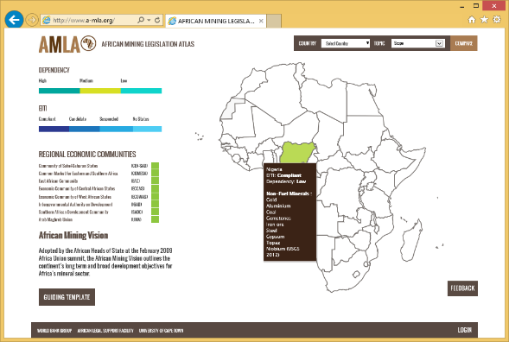
The user can also hover over the Dependency key to show on the map the Dependency status of each African state (see the following screen shot).
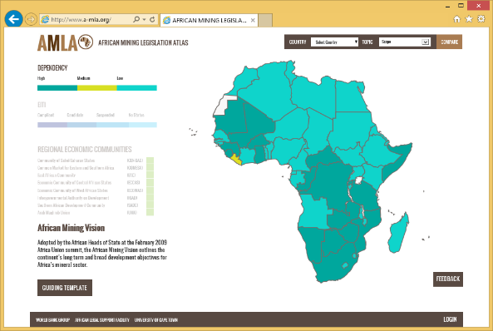
The user can also hover over the EITI key to show on the map the EITI status of each African state (see the following screen shot).
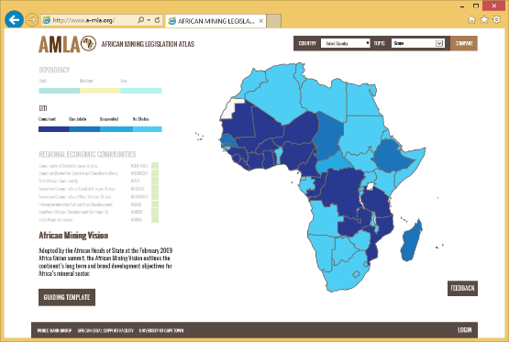
The list of Regional Economic Communities is also interactive and as the user hovers over each community the map changes to highlight the member countries (see following screen shot).
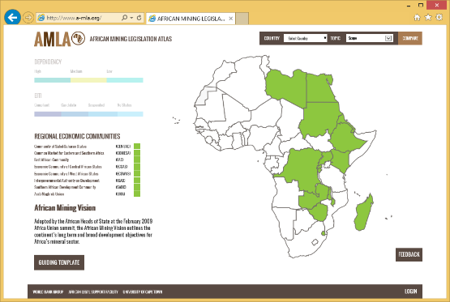
There is also the ability for users to pass on feedback to the AMLA team via the Feedback button located in the bottom right of the home page. When selected the following form is presented.
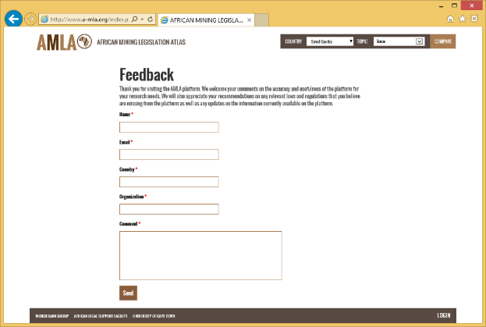
Mandatory form inputs are highlighted with a red asterix.
When the Send button is clicked it sends the completed form to a central AMLA support email where it can be responded to.

Country Pages
A user can get more information on a specific country by clicking on that country from the home page map.
When a country is selected the following screen is displayed featuring a map of the country, a country summary relating to its mineral legislation and a list of available documents.
The screen layout is as follows.
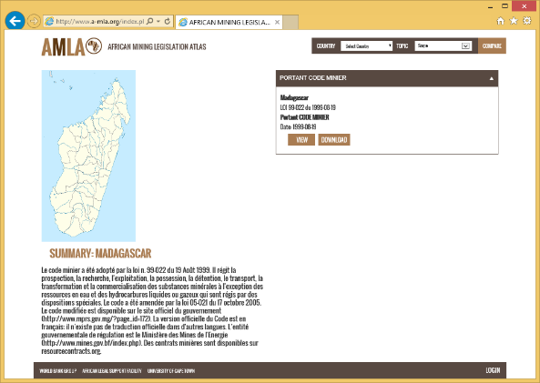

View Legislation
From the country page, a user can view that specific countries legislative documents. By simply clicking on the View button a user friendly display is launched with the full text, word search and interactive contents listing.
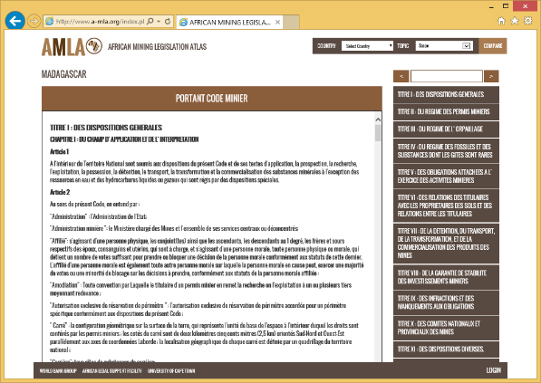

Navigate Content
If a user clicks on a specific chapter a drop down box appears with sub-sections and articles for quick navigation through the document.
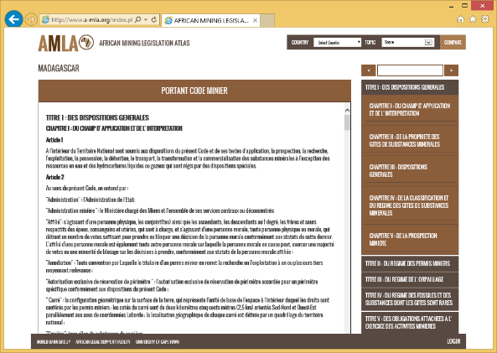
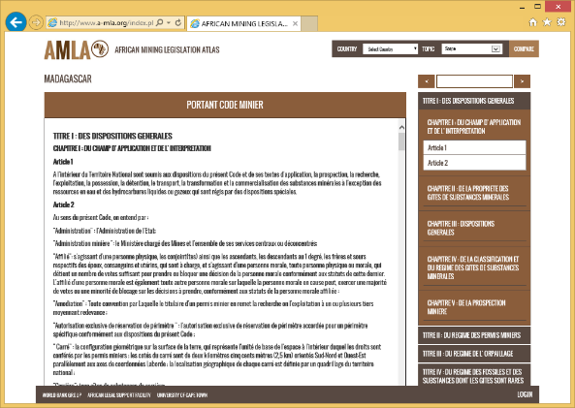

Search Content
If a user wishes to locate a specific word or phrase within the document, they type the word or phrase into the search bar and the next instance of that word or phrase is found and highlighted.
They can tab through each instance of that word of phrase by simply using the left and right arrow head buttons.
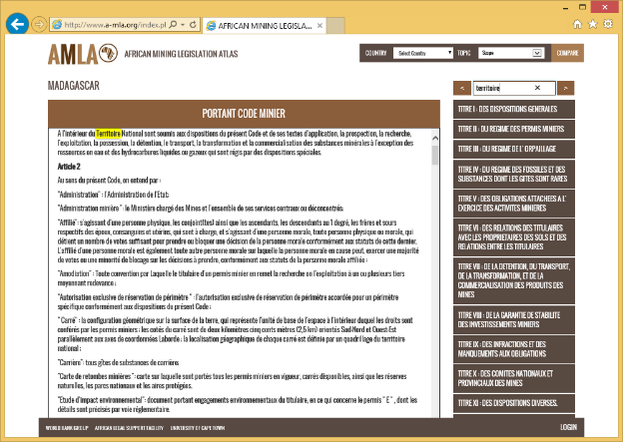

Print and Download Document
If a user wishes to print a document they can do so by scrolling to the bottom of the page and clicking on the Print button.
The original mining act in PDF or Word format can also be downloaded by clicking on the Download button.
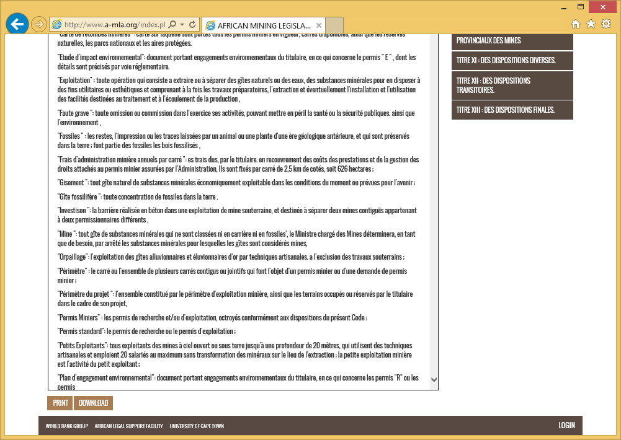

Country Comparison Feature
One of the key features of the AMLA platform is its ability to compare two countries legislation based on specific common taxonomy.

Step 1 – Select Countries
The first step is to select the two countries you wish to compare.
In the top right hand corner of the screen is the Comparison bar. Click on the Countries box and a drop down list of countries will appear.
Click on up to 2 countries from that list.
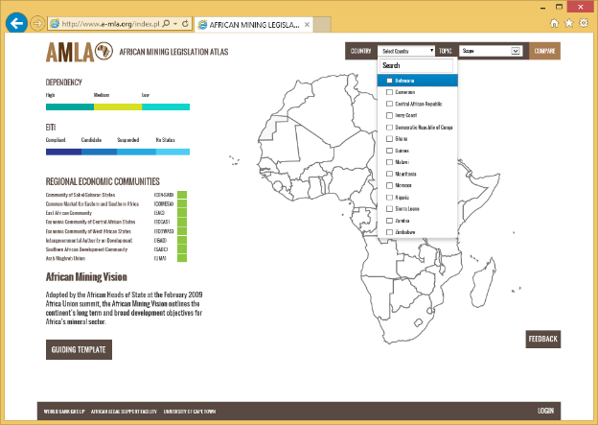

Step 2 – Select Common Taxonomy Criteria
Step 2 is to select the specific taxonomy or topic you wish to compare. Click on the Topic box and a drop down menu of all the available topics or common taxonomy will be displayed.
Scroll until you find the topic you wish to compare and select it.
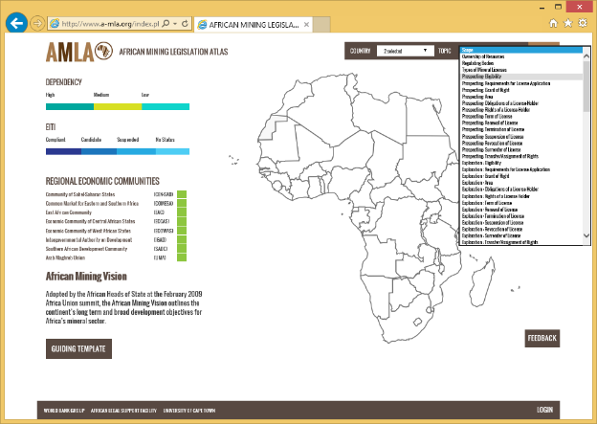

Step 3 – Compare
Now that the countries and topics have been selected, click on the Compare button to launch the comparison screen.
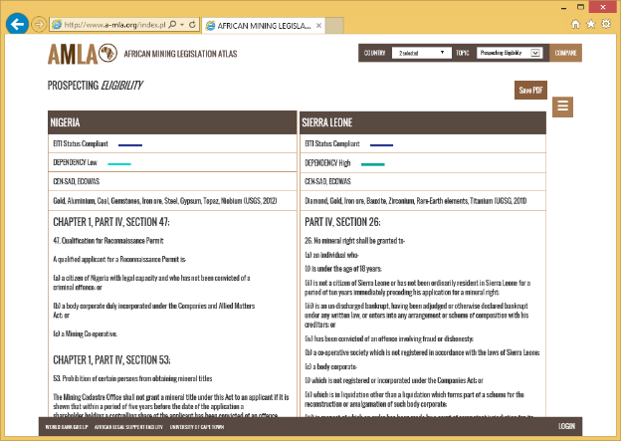
The two countries appear side by side to enable a very quick and easy comparison to be made.
Additional information such as the EITI and Dependency status, Economic Communities and non-fuel minerals also appear to provide additional comparison data.

Step 4 – Save Results
A user can save the results of the comparison feature by clicking on the Save PDF button in the top right hand corner of the screen. This saves a copy onto the users device for offline reference.

Step 5 – Update Comparison Query
A user can quickly change the comparison criteria by clicking on the side bar menu (highlighted as a brown button with three white lines).
This will launch the following side bar to enable the user to change the comparison criteria.
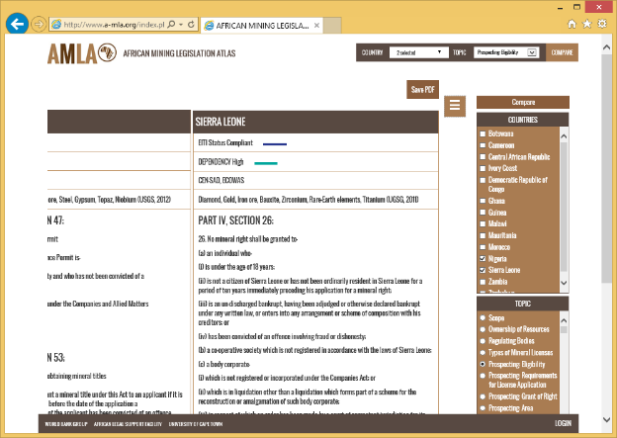
Once the revised criteria has been selected the user clicks on the Compare button to display the updated comparison results.

Contributor Functionality
A Contributor is a user that has been assigned the responsibility to add new documentation to the AMLA portal.
They can also link sections of specific documents to the topics or common taxonomy to enhance the comparison functionality.

TOP Tip
It is advisable to copy the original document from word into a text editor such as Notepad. This is to remove any text formatting as this will cause the user to have to manually edit the content after it has been cut and pasted into the respective text entry box.

Login
The first step is to log in with your predefined user credentials. The AMLA platform is for pre-registered users only and users cannot register themselves.
To login click on the Login button in the bottom right of the screen in the footer are of the portal.
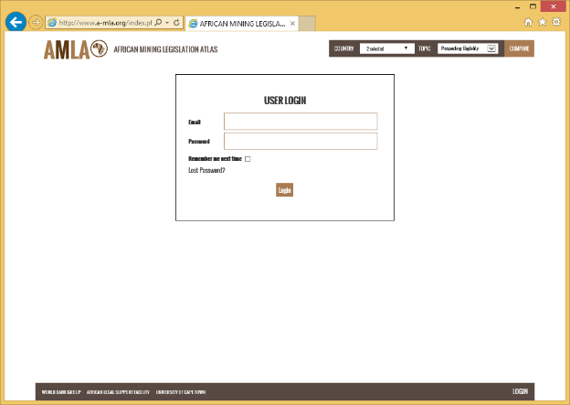
Enter your username and password and click on Login.
Once logged in, the user will be presented with a menu list of countries they have been assigned the responsibility for creating or editing country documentation.
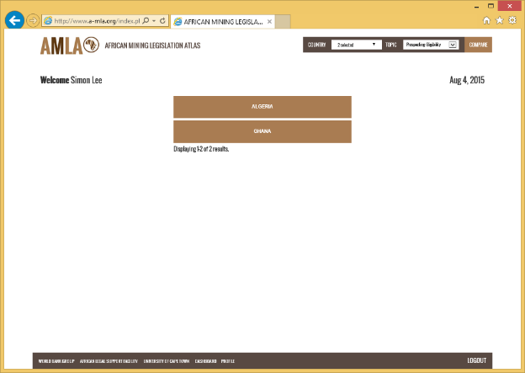

Edit Country Details
From the country menu, click on the country you wish to edit.
The following screen will then appear.
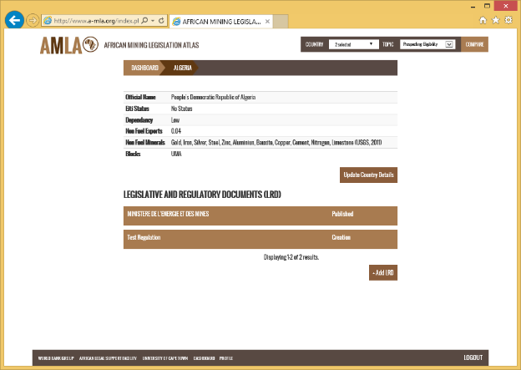
Click on the Update Country Details button.
A pop-up will appear which can be edited.
From within this pop-up you can change the following country specific information:
- Official Country Name e.g. Republic of Kenya
- Common Name e.g. Kenya
- Non Fuel Exports
- Country legislation summary including embedded hyperlinks to specific external websites.
- List of Non Fuel Minerals
- EITI Status
- Dependency Status
- Regional Body membership
Once any changes have been made, the user can click on the Save button to confirm the changes.
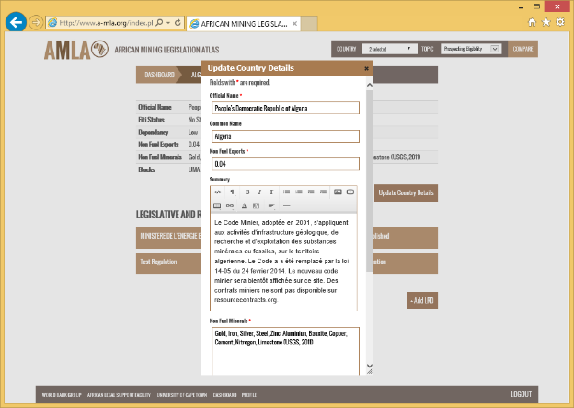

Create Primary Legislation and/or Primary Regulations
To create a new primary mining act (including amendments) or a primary regulatory document click on the Add LRD button.
The following pop-up will then appear.
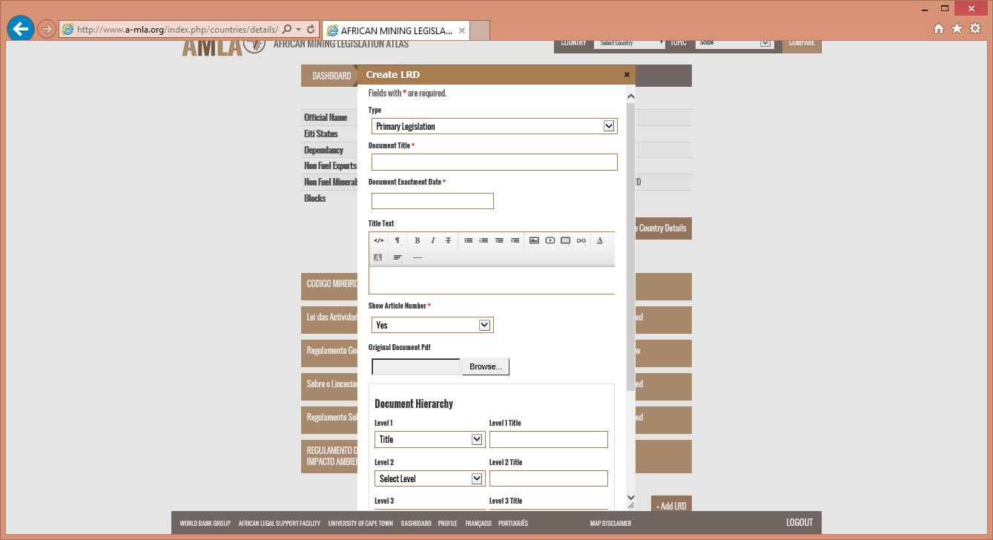
The pop-up form should be completed in the following manner:
Type | Select Primary Legislation or Primary Regulation from the drop down menu
Document Title | Enter the title from the original mining act, amendment or regulations document that you have sourced.
Document Enactment Date | This is the date the mining act was passed into law
Title Text | Some mining acts have some additional information on the title page that is not necessarily the direct title of the document. Add this information here.  NOTE: This is NOT the preamble
Show Article Number | Some documents have visible sequential numbering (see Nigerian mining act). Selecting “Yes” allows you as the user not to have to enter the number manually in the article title. Where a document has non sequential (see Angola mining act) this should be set to “No”
Original Document PDF | You can browse your computer for the original mining act and upload it to the portal. This will then be available to users via the Download button.

Document Hierarchy
Document hierarchy denotes the structure of the LRD being added. The AMLA CMS allows documents with up to 5 levels of hierarchy to be added. For example:
Title
Chapter
Part
Section
Article
All documents have at least one level of hierarchy and the majority have between 2 and 4 levels.
The table below denotes how the Document Hierarchy section of the pop-up should be completed.
Level 1 | From the drop down, select the type of hierarchy that is the first one in the document. E.g: Part or Title, or Chapter. When the document has only one hierarchy, select that (most probably Article).
Level 1 Title | The Level 1 title or name will change depending on the original language of the act. Type in the language of the specifying the hierarchy. E.g: for English language acts this may be Chapter, for French acts this may be Chapitre.
Level 2 to Level 5 | From the drop down menu select what category or type the second level in the hierarchy will be. E.g. Part. If the document does not have a second level anywhere in the document select “Not Applicable”

Once this information has been added, click on the Create button.

Create the Document Content
Once a document has been created it will appear as within a new brown box on the screen
Click on the new document from the document list and the following screen will be displayed.

Add Preamble
If your mining act has Preamble text, click on the Add Preamble button. This will launch the following pop-up.
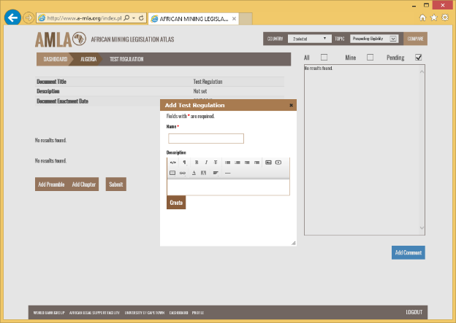
Enter the Preamble title e.g. ‘Preamble’ in the Name field.
Cut and Paste (or manually type) the text from the original mining act into the Description text box.
Click on the Create button.

Add Chapter
To add a specific chapter to the document click on the Add Chapter button. The following pop-up will be displayed.
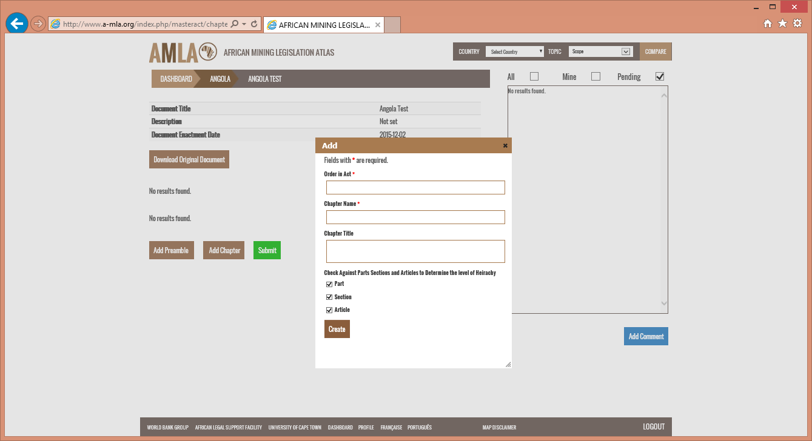
The pop-up form should be entered as follows:
Order in Act | This is the Chapter number as it appears in the table of contents. This is required as in some cases there may be collaboration between one or more person adding in a mining act and therefore the system does not presume that the order is based on the time that the chapter was added
Chapter Name | This is the name of the chapter as it appears in the original act (which may be Title, or Titre, or Part, etc.
Chapter Title | Some mining acts have additional chapter title information and this can be added here.
Hierarchy Check Boxes | To accommodate LRD such as the Nigerian mining act that has differing sub sections in each chapters we have enabled you to select what sub categories. Simply select what sub-categories are required.

Once the chapter information has been added the user clicks on the Create button. The newly created chapter will then appear in the list.

Add Part
To add a part to a chapter, click on the chapter you wish to edit. The following screen will be displayed.
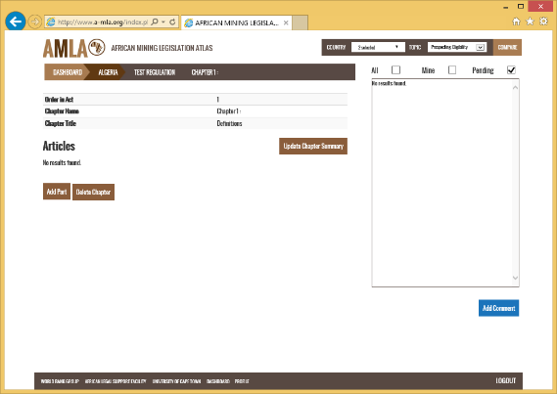
Click on the Add Part button and the following pop-up will appear.
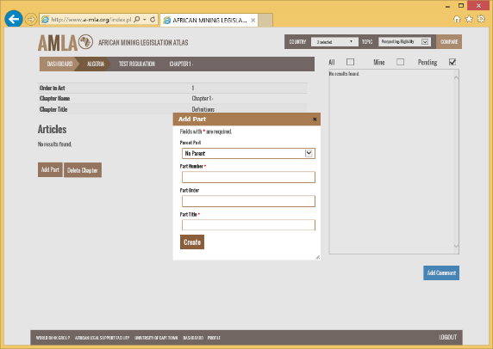
The pop-up form should be entered as follows:
Parent Part | This should only be changed if the Part is linked to another part within the same chapter.
Part Number | This is the Part number as it appears in the table of contents. This is required as in some cases there may be collaboration between one or more person adding in a mining act and therefore the system does not presume that the order is based on the time that the part was added.
Part Order | Leave this blank.
Part Title | Enter the title of the part as it appears in the original act.

Once the form has been completed, click on the Create button to create the new Part. This will then be displayed in a brown box on the screen.
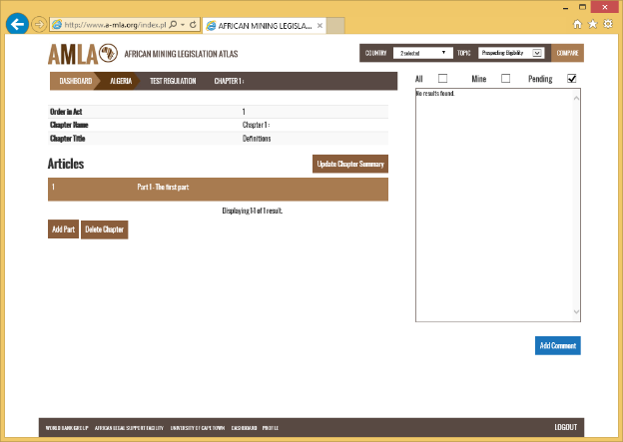
To add Sections and or Articles to the LRD click on the Part you wish to edit. The following screen will be displayed.
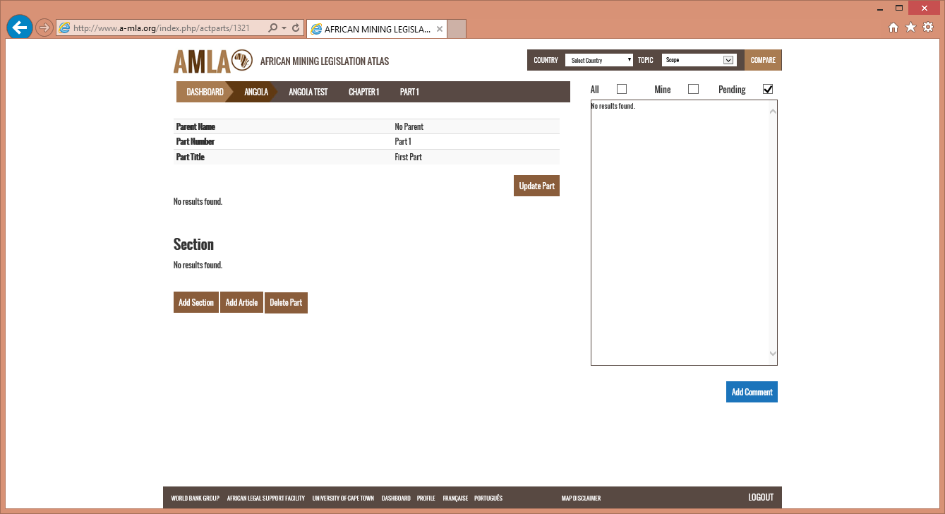

Add Section
The same process as adding a Part will be replicated if the mining act has Sections in addition to Chapters and Parts.

Add Article
To add an article to the act, click on the Part or Section you wish to edit and the following screen will appear.
Click on the Add Article button and the following pop-up will appear.
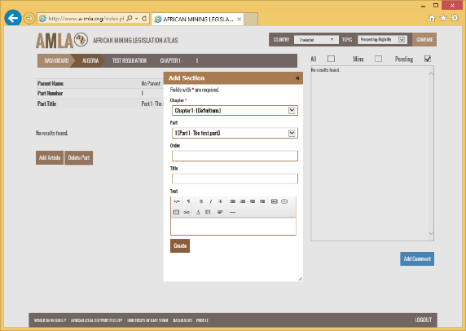
The pop-up form should be entered as follows:
Chapter | This is automatically populated based on your current location.
Part | This is automatically populated based on your current location.
Order | This is the article number as it appears in the document. This is required as in some cases there may be collaboration between one or more person adding in a mining act and therefore the system does not presume that the order is based on the time that the article was added.
Text | This the article content taken directly from the original act.

Once the form has been completed, click on the Create button to create the new Article. This will then be displayed inside a brown box on the screen.
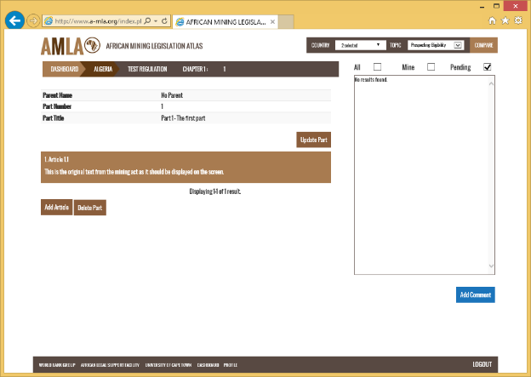
This process is repeated until the entire mining act has been added.

Submit for Review
Once a document has been fully added it has to be sent for review. To do this you need to navigate back to the document landing or root page.
For this you can use the horizontal breadcrumb bar and click on the document name; in our example this is TEST REGULATION.
Click on the Submit button. A confirmation pop-up will appear (see screen shot below).
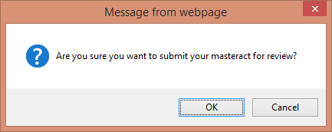
Click on “OK” and the following screen will then be displayed confirming your document has been submitted for review.
If you now click on the Country name in the breadcrumb bar (e.g. ALGERIA) the following screen will be displayed.
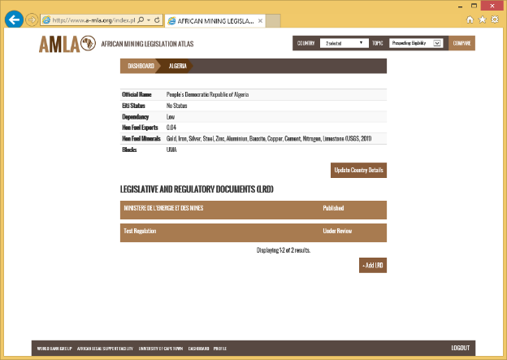
It should be noted that the status of “Test Regulation” has now changed to Under Review. If a user now clicks on that document they cannot make any further changes.

Create Related Legislative and Regulatory Documents
To add related legislative and regulatory documents click on the Add LRD button.
The following pop-up will then appear.
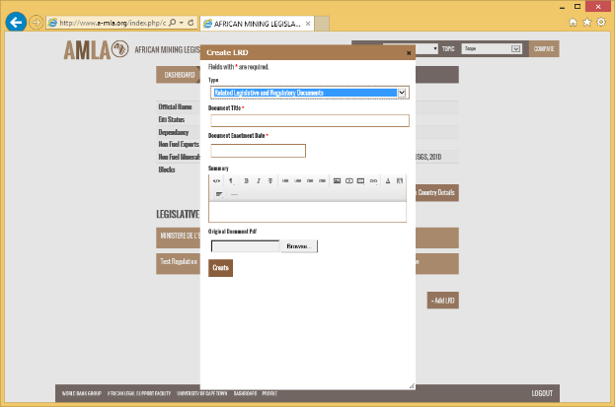
The pop-up form should be completed in the following manner:
Type | Select Related Legislation and Regulatory Documents from the drop down menu.
Document Title | Enter the title from the related document that you have sourced.
Document Enactment Date | This is the date the mining act was passed into law.
Summary | Enter the summary text relating to the document.
Original Document PDF | Upload the original document in PDF format.

Once this information has been added, click on the Create button.

Submit for Review
To submit a Related Legislation and Regulatory Document for review, click on the desired document from the list.
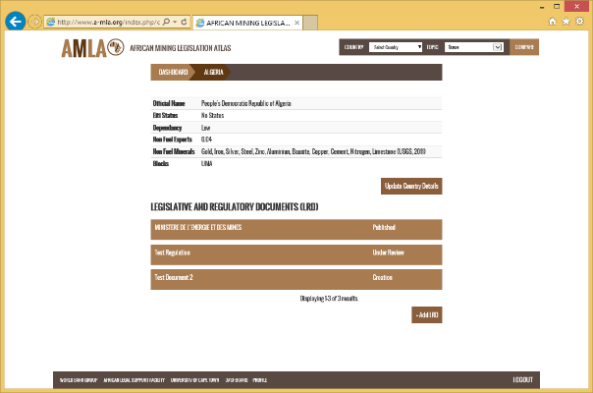
The following screen is then displayed.
Click on the “Submit” button. The following screen will then be displayed.
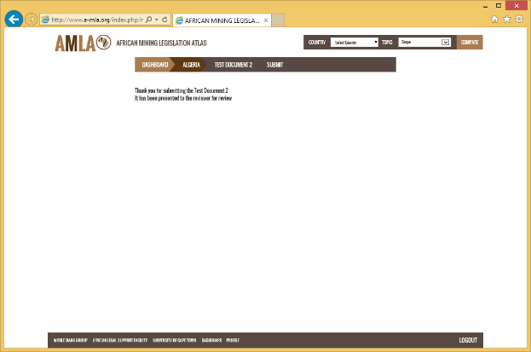

Add Comparison Text
The Comparison feature allows a user to compare one countries principal mining act against that of another country based on specific topics. Contributor users can create these comparisons through the following actions.
Once you have logged in, select a country. Scroll down to the Comparison Admin section, as shown in the screen shot below.
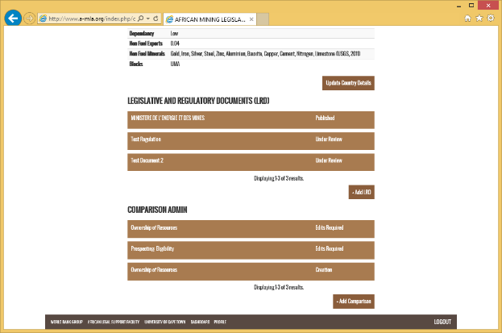

Add Comparison
Click on the “Add Comparison” button. The following pop-up will then appear.
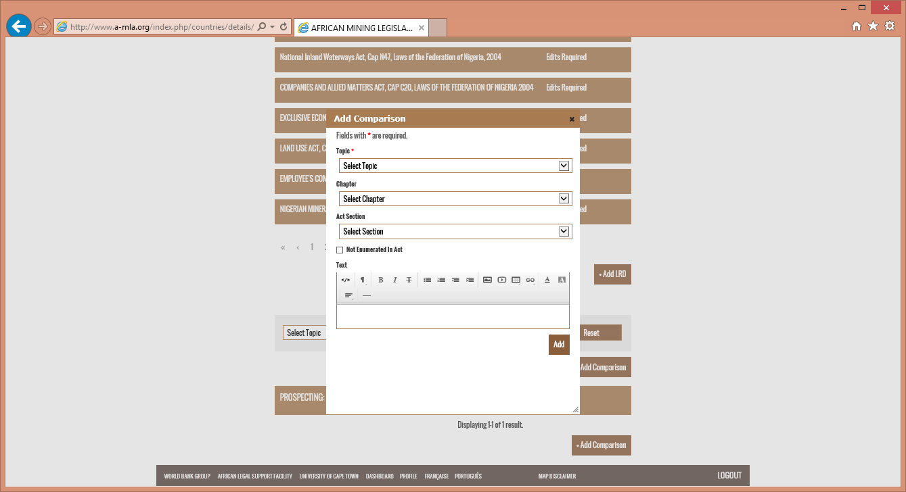
The pop-up form should be completed in the following manner:
Topic | Select a Topic (common taxonomy) from the drop down list.
Chapter | Select the chapter related to the chosen Topic.
Act Section | Select the Section related to the chosen Topic.
Not Enumerated in the Act | If the selected Topic is not enumerated in the mining act, them you simply click in the box and you do not need to select Chapter or Section.

Full Section to be Used
If you click on the “Add” button at this point the system will automatically add the entire section from the Primary Act/Amendment to the Comparison feature for the selected Topic.

Partial Section to be Used
In the event that only a small part of the Section/Article is related to the chosen Topic, then you copy and paste the specific text into the “Text” box and then click on the “Add” button. Make sure that the formatting is accurate (spacing between paragraph within the same article, and spacing between articles/sections).

Multiple Sections Relating to One Topic
Where there are multiple Sections or Articles relating on specific Topic, repeat the above actions until all related sections have been added to the chosen Topic.

Submit Comparison Text for Review
To submit a Comparison Text for review, click on the desired Topic from the list.
The following screen will then be displayed.
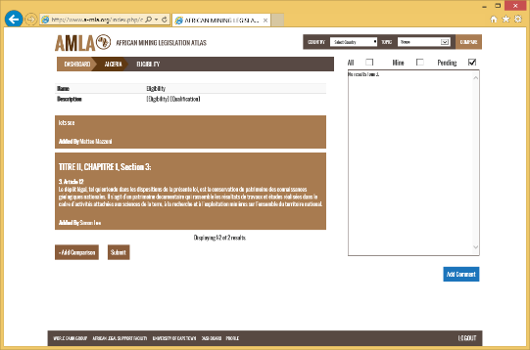
The screen displays a list of all the sections associated with the Topic selected. To submit the selected Topic for review click on the “Submit” button. The following screen will be displayed.
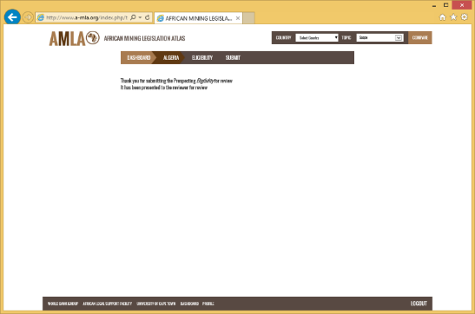

Manage Review Comments
Once a document of comparison topic has been reviewed, the reviewer may send back to the Contributor for editing. To guide the Contributor there will be comments that will be added by the reviewer relating to the specific document or comparison.

LRD Review Edits

Review Results
When a document or comparison text has been reviewed and edits are required the status of the relevant document of comparison text will change (see screen shot below) to “Edits Required”.
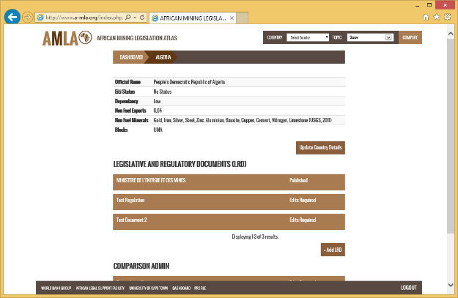
Click on the document to see what edits are required. The following screen will then be displayed.
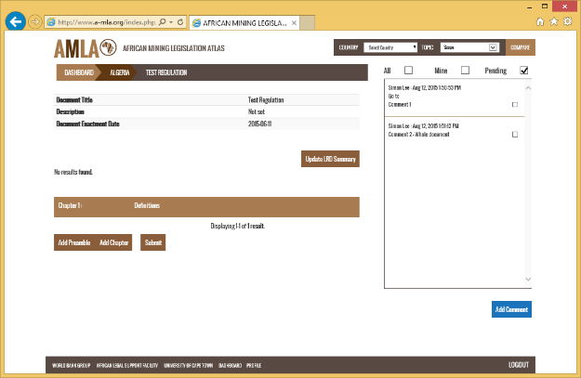
The right part of the screen displays a box that contains the comments from the reviewer. The reviewers name is visible (there may be more than one reviewer for each country) along with the date when the comment was added.
Above the comments box there is a simple filter system. The three options are as follows:
All | All comments made in relation to the document or comparison.
Mine | View comments added only by “me”.
Pending | View any comments that have not been checked, e.g. have not been completed.

Make Edits
A reviewer can make generic or specific comments. Generic comments cover the entire document and are not linked to a specific chapter, part or article of a document. Specific comments are linked.
You can tell a specific comment by the occurrence of the text “Go To” under the comments author and date/timestamp.
Click on the “Go To” hyperlink and the system will take you to the specific article in the document that needs to be edited.
In the screen shot below, the Go To has taken the contributor to Article 1.1
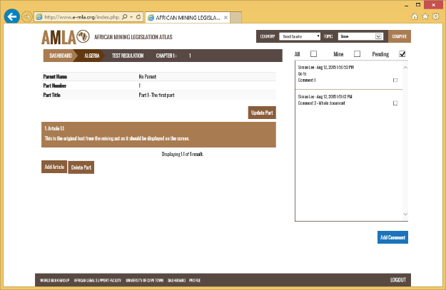
Click on the article to open the edit view pop-up.
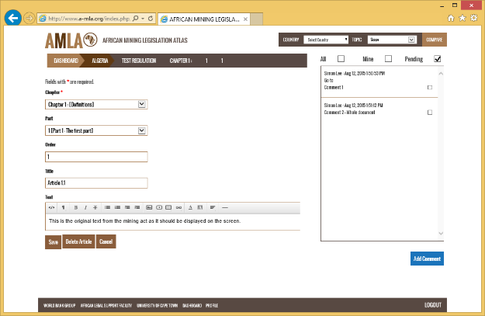
Once the edits have been completed, click on the “Save” button.
If at any point you need to revert back to the original text, simply click on the “Cancel” button.
If the article is recommended for deletion, click on the “Delete” button. The following pop-up will be displayed.
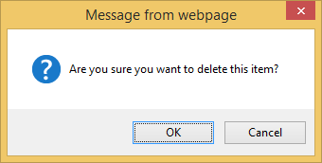
Click on the OK button to confirm the deletion or Cancel to keep the article.

Complete Review
As you complete each action requested in the comments you click the box to the right of the comment. This removes it from the “Pending” list.
To view the completed actions you will now need to select “All” from the filter above the comments box. The following will then be displayed.
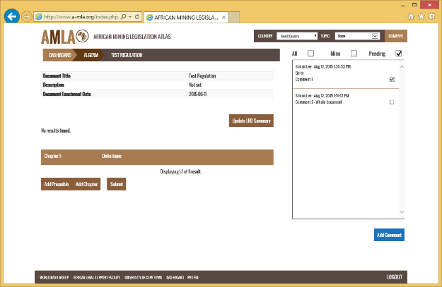
Take note of the “ticked” box next to the comment.

Add your own Comments
The Reviewer may have asked a questions or sought clarification without necessarily requiring an edit to a specific document of comparison. You can respond to this query or add a comment of your own by clicking on the “Add Comment” button. This will launch the following pop-up.
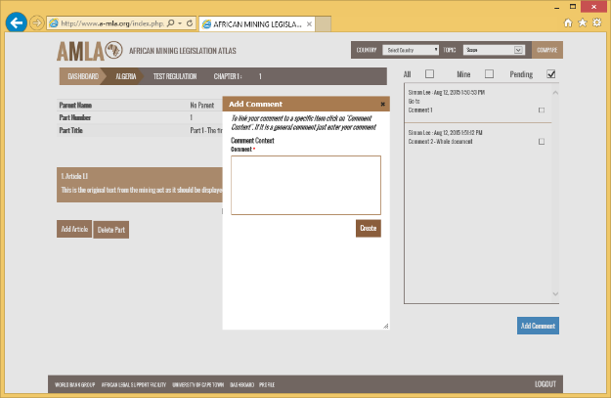
If you want the comment to be related to a specific article in the LRD then click on the “Comment Context” hyperlink. The pop-up will then show a drop down menu with a list of available articles in the document.
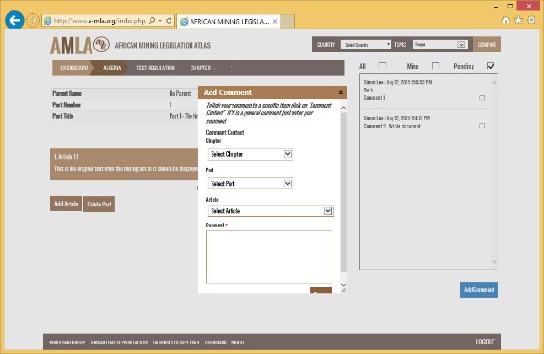
Select the Chapter, Part and Article you wish the comment to be related to.
Enter your text in the Comment box and then click on the “Create” button. The comment will be added to the Comments box, see below screen shot.
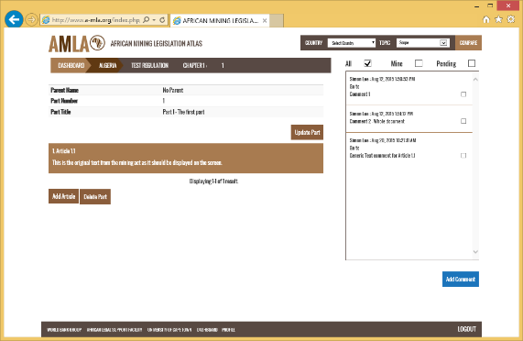
If you click on the “Mine” filter, you will now only see the comment(s) you have added. See screen shot below.
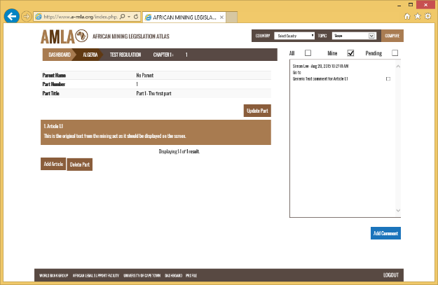

Resubmit for Review
Once all the comments have been actioned, the user can resubmit the document or comparison text for review.
Click on the “Submit” button once ready and the changes will be submitted back to the review team.

Comparison Text Review Edits

Review Results
When a comparison text has been reviewed and edits are required the status of the relevant comparison text will change (see screen shot below) to “Edits Required”.
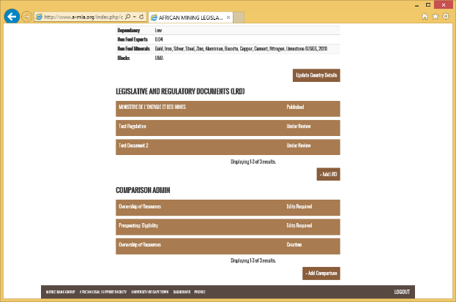
Click on the document or comparison text to see what edits are required. The following screen will then be displayed.
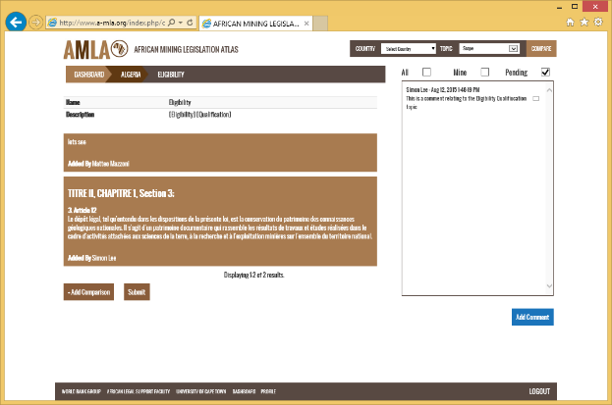
The right part of the screen displays a box that contains the comments from the reviewer. The reviewers name is visible (there may be more than one reviewer for each country) along with the date when the comment was added.
Above the comments box there is a simple filter system. The three options are as follows:
All | All comments made in relation to the document or comparison.
Mine | View comments added only by “me”.
Pending | View any comments that have not been checked, e.g. have not been completed.

Make Edits
A reviewer can make generic or specific comments. Generic comments cover the entire document and are not linked to a specific chapter, part or article of a document. Specific comments are linked.
You can tell a specific comment by the occurrence of the text “Go To” under the comments author and date/timestamp.
Click on the “Go To” hyperlink and the system will take you to the specific article in the document that needs to be edited.
In the screen shot below, the Go To has taken the contributor to the Eligibility topic.
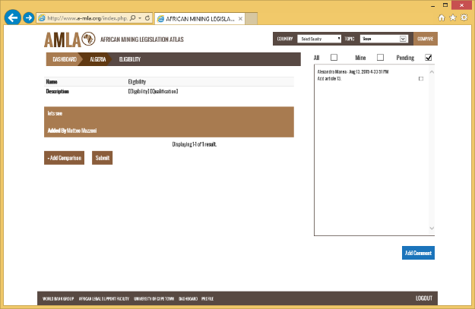
Click on the comparison text and the following screen will be displayed.
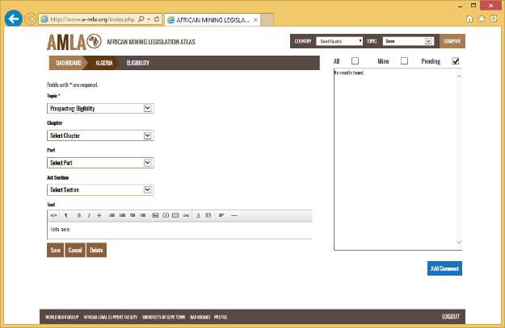

Once the edits have been completed, click on the “Save” button.
If at any point you need to revert back to the original text, simply click on the “Cancel” button.
If the article is recommended for deletion, click on the “Delete” button. The following pop-up will be displayed.
Click on the OK button to confirm the deletion or Cancel to keep the article.

Complete Review
As you complete each action requested in the comments you click the box to the right of the comment. This removes it from the “Pending” list.
To view the completed actions you will now need to select “All” from the filter above the comments box. The following will then be displayed.
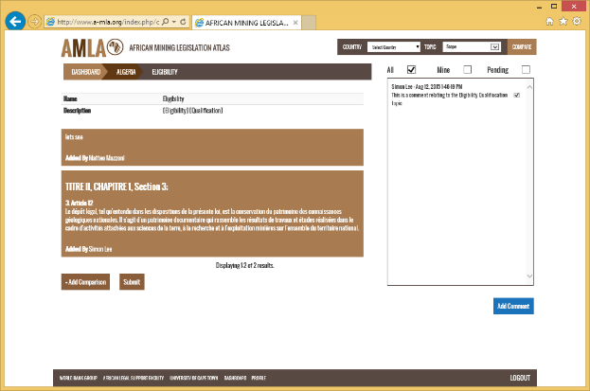
Take note of the “ticked” box next to the comment.

Add your own Comments
The Reviewer may have asked a questions or sought clarification without necessarily requiring an edit to a specific document of comparison. You can respond to this query or add a comment of your own by clicking on the “Add Comment” button. This will launch the following pop-up.
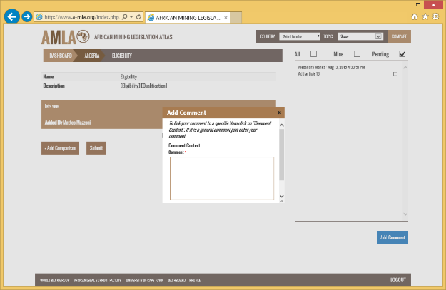
Enter your text in the Comment box and then click on the “Create” button. The comment will be added to the Comments box, see below screen shot.
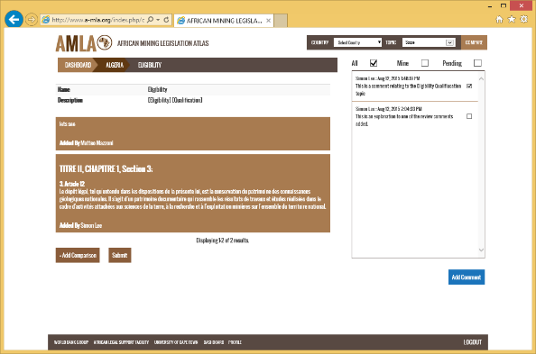
If you click on the “Mine” filter, you will now only see the comment(s) you have added. See screen shot below.
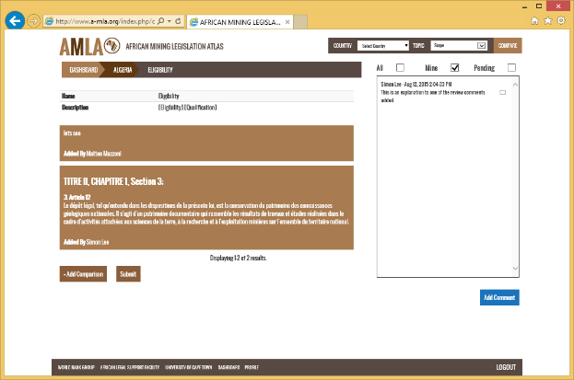
If you want the comment to be related to a specific article in the LRD then click on the “Comment Context” hyperlink. The pop-up will then show a drop down menu with a list of available articles in the document.
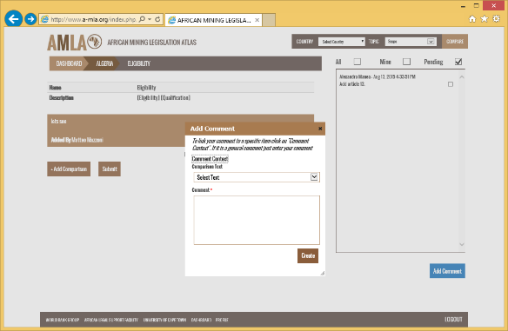
From the “Comparison Text” drop down menu, select the text to associate your comment to.
Then add your comment in the “Comments” text box and click on Create. The comment will be added to the side bar.
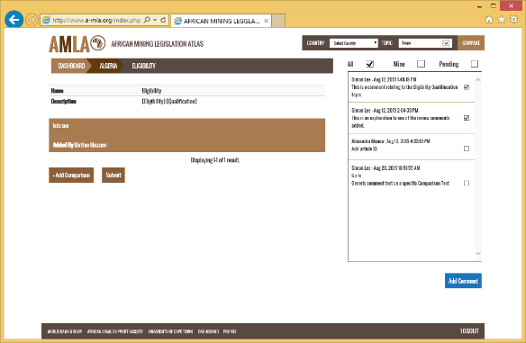

Resubmit for Review
Once all the comments have been actioned, the user can resubmit the document or comparison text for review.
Click on the “Submit” button once ready and the changes will be submitted back to the review team.

Extractive Industries Transparency Initiative

